Reviewers: Use this special for when no new bridge plans are provided. Remove sections that are not required. Update System G paragraphs 2.3, 2.3.1 & 3.1 to System H when doing weathering steel or when required. Remove sections that are not required. Be sure to define limits of painting clearly.

Update section 2.4 if a prime coat is used.

We don’t use Calcium Sulfonate Primer unless it is approved by your SPM and on the memo. Remove the notes about it when they are not needed.

STRUCTURAL STEEL PROTECTIVE COATING REQUIREMENTS 10/27/14

1.0 Description. This provision contains the requirements for applying the structural steel protective coating for the bridges in this project.

2.0 Construction Requirements.

2.1 Straps Removal. Exposed portions of straps for stay-in-place forms shall be removed prior to surface preparation. Flame cutting will not be permitted. The contractor shall exercise care not to damage the existing structure during removal. Any damage sustained to the remaining structure as a result of the contractor's operations shall be repaired or the material replaced as approved by the engineer at the contractor's expense.

2.2 Slab Drains and Stay-In-Place Forms. The stay-in-place forms, the slab drains and slab drain brackets shall not be recoated or overcoated or damaged during the painting operation. Any portion of the slab drain bracket that is blast cleaned shall be recoated with System G. Any damage sustained as a result of the contractor's operations shall be repaired or the material replaced as approved by the engineer at the contractor's expense.

2.3 System G. System G shall be in accordance with Sec 1081. Surface preparation of all existing steel shall be in accordance with Sec 1081 for “Recoating of Structural Steel (System G, H or I)”. The tint of the prime coat for System G shall be similar to the color of the field coat to be used. The color of the field coat shall be Gray (Federal Standard #26373).

2.3.1 Expansion Joint Locations. The surfaces of all structural steel located under the joint(s) or location as mentioned in the table below, shall be field coated with complete System G within a distance 1.5 times the girder depth, but not less than 10 feet from the centerline of joint each direction or not less than 10 feet from front face of backwall of end bent. Complete System G includes field application of inorganic zinc primer, intermediate field coat and finish field coat.

Bridge No. | Joint Location
A04601 | None
A05091 | Bent No. 1
A05241 | Bent No. 1 & 4
A07631 | Bent No. 5
X07581 | None

2.4 Calcium Sulfonate System. Calcium Sulfonate System shall be in accordance with Sec 1081 with the exception that no Calcium Sulfonate Primer will be used. Surface preparation of the existing steel shall be in accordance with Sec 1081 for “Overcoating of Structural Steel (Calcium Sulfonate System)”. The rust penetrating sealer shall be applied to the surfaces of all bearings, overlapping steel plates, pin connections, pin and hanger connections and other locations where rust bleeding, pack rust, layered rust and rusting is occurring. The color of the topcoat shall be Gray (Federal Standard #26373).

2.5 Painting Overlap Detail.
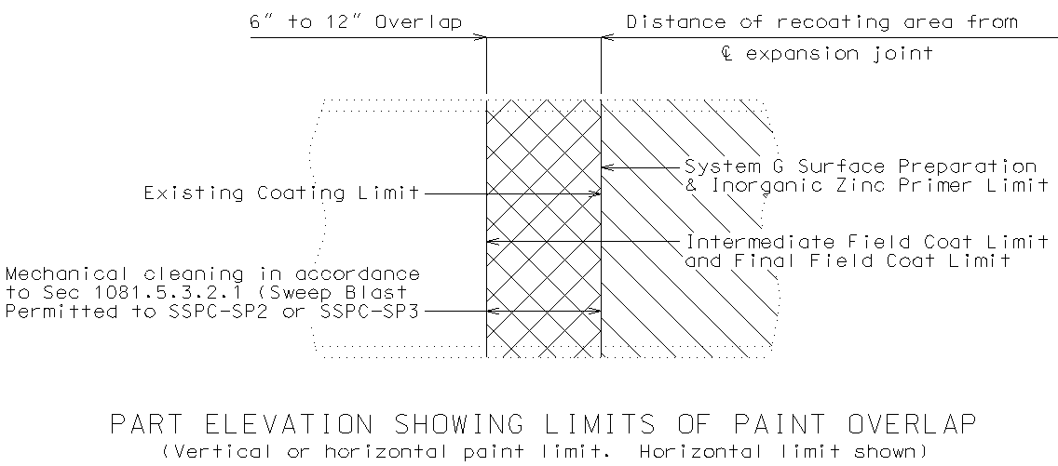

2.5 Painting Overlap Detail.

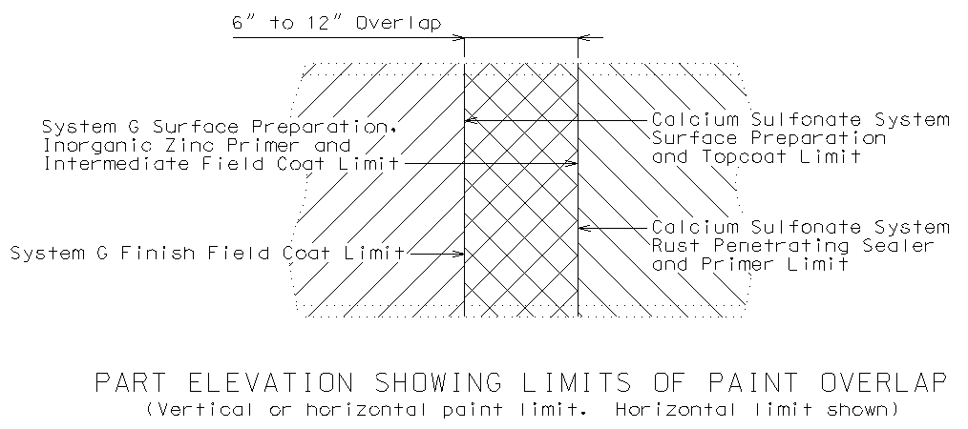
3.0 Method of Measurement.

3.1 System G. The surface preparation, prime coat and intermediate and finish field coat will be measured to the nearest 100 square feet in accordance with Sec 712 and the “Limits of Coating Application” in accordance with Sec 1081.

3.2 Calcium Sulfonate System. The calcium sulfonate rust penetrating sealer will not be measured. The surface preparation for overcoating structural steel, calcium sulfonate primer and calcium sulfonate topcoat will be measured to the nearest 100 square feet (10 m²) in accordance with Sec 712 and the “Limits of Coating Application” in accordance with Sec 1081.

4.0 Basis of Payment. Payment for the above described work, including all material, equipment, labor and any other incidental work necessary to complete this item, will be considered completely covered by the following pay items:

“Surface Preparation for Recoating Structural Steel” per square foot.
“Field Application of Inorganic Zinc Primer” per square foot.
“Intermediate Field Coat (System G)” per square foot.
“Finish Field Coat (System G)” per square foot.

“Surface Preparation for Overcoating Structural Steel” per square foot.
“Calcium Sulfonate Rust Penetrating Sealer” per lump sum.
“Calcium Sulfonate Primer” per square foot.
“Calcium Sulfonate Topcoat” per square foot.

